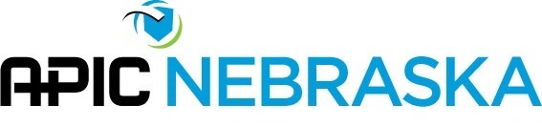
We are excited to provide an opportunity to recognize creativity in infection prevention and control through the Bright Ideas Award.
Eligibility: All members are eligible regardless of the number of past submissions or awards
Criteria: Develop a “bright idea” (creative idea) that has improved infection control practices at work, in the community or at play.
Application: The member must submit an application by February 3rd to the Awards Committee. The application includes a short description of your “bright idea”. Attached handouts, pictures, etc. is encouraged.
Award: All applicants receive an award to recognize your creativity at the annual meeting in March.
Name |  |  | Position
Employer |  |  | Email
What was identified problem?

What was your Bright Idea?

What was the outcome?

Return via email to Lindsy Kroenke lkroenke@madonna.org

